54

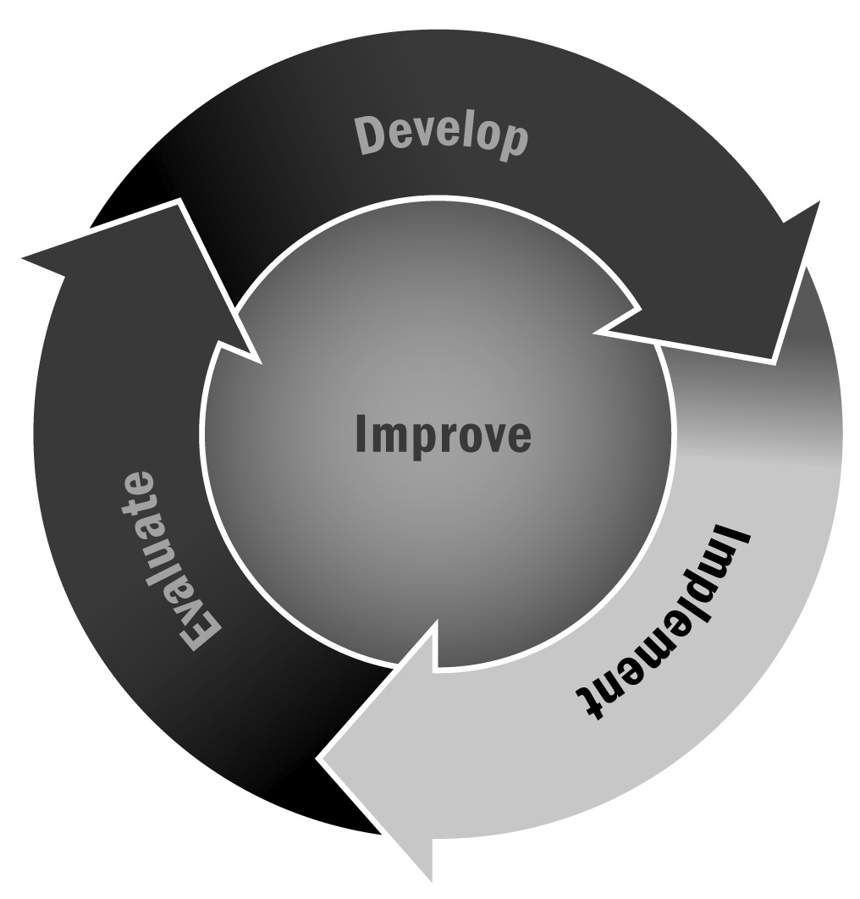
Tips for Data-Sharing Agreements With School Partners
In Chapter 3, you learned that having access to data on youth and young people’s educational experience is important for program planning and reporting. Developing a data-sharing agreement with the school or district you partner with will facilitate your program’s ability to access and use these data.
Directions: Consider these tips when developing a data-sharing agreement for your program and partners. This may not be exhaustive, but it can facilitate a discussion with your school partners and get you started thinking about data. You can brainstorm about your data needs and ideas in the space below each question so you will be prepared with notes for your discussions about data with partners.
When you are writing a data-sharing agreement, there are a few key concepts to consider. Laws and regulations may differ among states or cities, so be sure to understand the local context and legal requirements when developing a data-sharing agreement. Note that this tool focuses on requesting data from a school or school district, but certain elements may still apply if you identify other partners that may be able to share data that will help your program.
Why do you want data from your partner school district?
A key question to consider is why you want the data from the school district. Is this for an external evaluation? Keeping track of participants’ progress in school? How you plan to use data has implications for what data will be shared and how you will use it.
List the purposes for the data you plan to request.
What type of data are you looking for?
The data-sharing agreement should lay out in detail the data you hope to obtain. Are you looking for grades, test scores, or behavior data? Which years, and how often would you like them to be updated? Including this information in the agreement ensures that you have access to useful data and that the school district is up to date on what you are requesting. Try to list all the fields or variables you would like to access, as well as the level of data (e.g., student level, school level) and the time period you would like the data to cover.
List the type of data are you looking for.

What types of laws in your state or city govern the use of data pertaining to youth?
The requirements for data sharing may differ among states and other entities. Be aware of the requirements in your area, and, if necessary, consult an expert in this area, such as a data specialist from the school district or partners who may already have data-sharing agreements with the school.
What are the relevant laws in your state? If you’re not sure, who might you contact as a resource?
How does the Family Educational Rights and Privacy Act (FERPA) apply to your state and program?
FERPA is a critical component in sharing school data. It is a federal law that governs how student-level data can be used and shared. In January 2012, FERPA was amended to make it easier to share student-level data by clarifying ambiguities and addressing certain barriers. There are resources available to help you navigate FERPA both at the federal level and in your state, so make sure you address FERPA regulations when you discuss data with your partners and develop your agreement.
What elements of FERPA are you familiar with, and how do they apply to your program? If you’re not sure, what or who might be a good resource to find out?
Who is going to have access to your data?
It is important to specify what staff members in your organization will have access to the student data, especially if the data involve sensitive or personally identifiable data (such as Social Security numbers). It is possible that, depending on the sensitivity of your data, you will have to get security clearance or confidentiality agreements specifically for the individuals who will have access to the data (which includes storing, managing, and analyzing data).
List the staff members who will have access to the data, their roles at your organization, and how they will interact with the data.

How are you going to transfer and store your data?
When considering the sensitivity of your data, it is also important to think about how you are going to transfer data and store the data on site. What format will the file be in (e.g., Excel, SPSS, comma- or tab-delimited text file)? Is it going to be transferred via secure file transfer protocol (FTP), CD, or USB drive? Will it need to be encrypted? Will you be storing it on a server or hard drive, and who will have access to this machine? These questions may depend on how sensitive and identifiable your data are. Not all data may require encryption, for example, but it is important to consider data security when developing an agreement with the school.
Describe how you plan to transfer and store the data. If you’re not sure, list what you would need to find out before making this decision.
How are you going to dispose of the data when you are done using them?
Certain entities may require that you destroy the data after a certain period of time for security reasons. This may depend on requirements and data sensitivity, but you may need to include a section on how and when you will dispose of the data. Some agencies require this as part of their data agreements.
Brainstorm feasible options for how to dispose of data at your program. It is likely that this will be determined by the school, rather than your program, but you can think ahead about what you can propose that may be easier for your program.
How are you going to identify youth in your data?
In order to keep track of the young people in your data, youth need to be uniquely identified. However, the ID that you use may have implications for your agreement and how you use or store your data, depending on how much other information you can learn about each young person based on this ID. For example, using Social Security numbers is highly identifiable and sensitive; however, it likely will not be necessary to have access to youth’s Social Security numbers in order to use their academic data. One option is to generate an ID number specifically for your program that the school can use to match and that would not provide unnecessary information on youth.
Brainstorm about whether you need identifiers such as Social Security numbers in your data and what systems you might want to use to link youth. For example, if you are hoping to link youth to other systems such as juvenile justice, what might the system use to identify youth? This may be an element that you have to rely on the school for, but if you have ideas, it may help to include them here.
When will you need the data?
Creating a timeline for when you will request and receive the data, as well as specifying which time periods you would like the data to cover, will allow the school district to plan for your data requests. This will also allow you to plan your analysis or evaluations around when important data become available.
Write down your ideal timeline for the analysis and when you would like to have the data.
How do you need to involve parents or guardians in data sharing?
Because participants are likely to be minors, you may need to obtain parental or guardian consent to ask for data regarding them. Review FERPA and state-level regulations and consider the best way to inform and obtain consent from parents or guardians. For example, you might include a consent form in the introductory packet when youth enroll in the program.
Brainstorm some ideas for how you could include parental or guardian consent in your program’s existing materials or processes.
How will you structure your data-sharing agreement?
Data-sharing agreements may take on different forms, depending on the requirements of your partner schools, your state, and other contextual factors. Below is a very high-level outline that may help guide you as you begin to structure an agreement and negotiate its terms with your partners.
Sample Outline for Data-Sharing Agreement
- Participants in the agreement
- Who possesses the data?
- Who is requesting the data?
- Data
- Purpose/reason for requesting data
- What type of data
- When the data will be available and provided to requester
- Compliance with Family Educational Rights and Privacy Act (FERPA) and other laws or regulations
- FERPA
- Obtaining consent from youth and/or parents as necessary

- Security measures
- How data will be transported, stored, and disposed of
- Who will have access to the data
- Other security precautions
- Other contractual or liability concerns
- The duration of the agreement
- How to change the agreement if necessary
- How and why the agreement may be ended by any participant
What resources are available to support you in developing data-sharing agreements and considering how to use data in your program?
A variety of available resources cover the above issues in greater detail. Check out the resources listed below to see how you can develop a strong data-sharing agreement and relationship with the schools you work with and other partners.

Resources and References
Ferber, T., & Evennou, D. (2011). First look: New FERPA regulations. Retrieved from http://forumfyi.org/files/First_Look_FERPA.pdf
Harvard Family Research Project. (2013). Data sharing resources for afterschool and expanded learning programs and systems. Retrieved from http://www.hfrp.org/publications-resources/browse-our-publications/data-sharing-resources-for-afterschool-and-expanded-learning-programs-and-systems
National League of Cities. (2012). Building management information systems to coordinate citywide afterschool programs: A toolkit for cities. Retrieved from http://www.nlc.org/Documents/Find%20City%20Solutions/IYEF/Afterschool/YEF_MIS%20Toolkit_2012.pdf
Partnership for Children and Youth. (2012). Data-sharing: Federal rules and best practices to improve out-of-school-time programs and student outcomes. Retrieved from http://expandinglearning.org/sites/default/files/ost_data-sharing_and_ferpa.pdf
The Urban Institute. (2013). National Neighborhood Indicators Partnership lessons on local data sharing (Online Guide). Retrieved from http://www.neighborhoodindicators.org/library/guides/nnip-lessons-local-data-sharing
The Wallace Foundation. (2012). After-school data: Six tip sheets on what cities need to know. Retrieved from http://www.wallacefoundation.org/knowledge-center/after-school/collecting-and-using-data/Pages/After-School-Data-What-Cities-Need-To-Know.aspx

